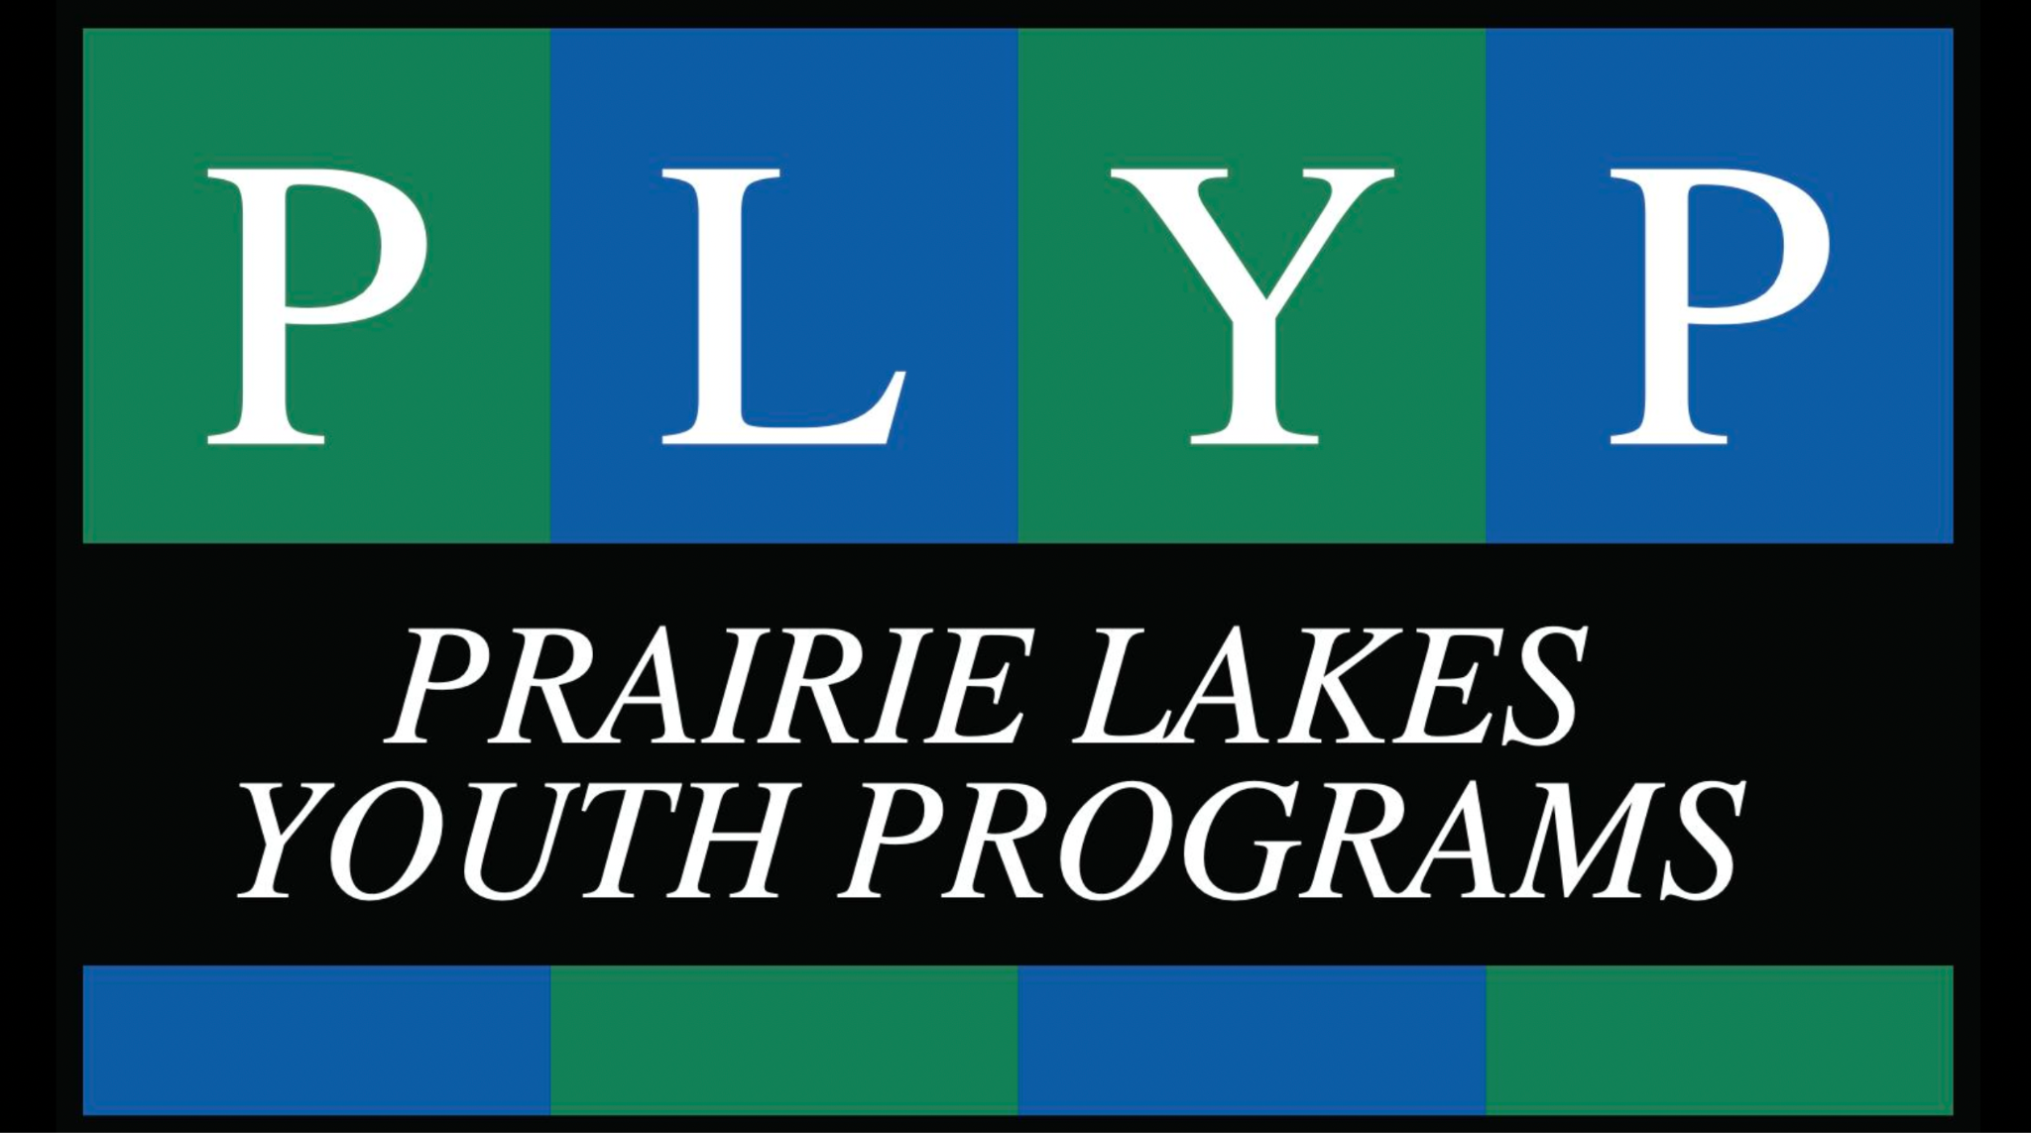
Prairie Lakes Youth Programs
1808 Civic Center Drive
Willmar, MN 56201
320-231-1729
prairielakes.net
Prairie Lakes Youth Programs Referral Form
Complete this form to refer a youth to our programs at PLYP.
Programs Include:
Toledo's Passage (Secure Detention and Residential Corrections Male and Female)
Leo's Legacy (Non-Secure Middle School Males)
Captain's Academy (Non-Secure High School Males)
Haven House (Community Based Group Home Females)
Integrity House (Community Based Group Home Males)
Questions and immediate assistance can be directed to: Holly Booth, Executive Director, holly@prairielakesyouth.org
Program Requested
Referral Date
Rationale For Placement Request
Name of Person Completing this Form
Youth Demographics
Youth Full Name
Preferred Name or Nickname
Date of Birth
Place of Birth
Gender Assigned at Birth
Gender Identifies As
Race and Cultural Heritage
Spiritual or Religion Affiliation
Placing Agency
Agency/County/Program Name
Referral Agent Name
Agent Phone Number
Agent Email
Legal Custodian Information
Is Legal Custodian Same as Parent
Legal Custodian Name
Custodian Phone Number
Custodian Email
Custodian Address
Parent Information
Parent Names
Parent Phone Numbers
Parent Emails
Parent Addresses
Education Information
Most Recent School Attended
City and School District
Contact Person at School (Name and Title)
Does the Youth Have an IEP
Current Grade in School
Medical History
Medical Needs or Supports
Any Allergies
Any Physical Disabilities
Any Physical or Medical Restrictions
Current Medications
Diagnostic Information
Most Recent DSM Diagnosis
Diagnostic or Other Assessments Completed
Strengths and Difficulties
Share the Trauma and Mental Health ACEs Impact Youth Has Experienced
Any Sexual Boundary or Vulnerability Concerns
Any Significant Aggression History or Current Behaviors
Share the Challenges and Difficulties Youth is Working to Overcome
Share the Achievements and Strengths Youth Demonstrates
Anything Else not Mentioned that we Should Know
Share the ‘Coolest’ Thing about this Kiddo
Placement Request
Length of Stay Requested
Any Services Requested During Stay
Placement Goals
Intake Date Requested
Administrative Review
Administrator Name
Date
Intake Decision/Program
Rationale
Placing Agency Notification

